**Spring Data JPA - Quick Example**CREATE DATABASE ormlearn;

USE ormlearn;

CREATE TABLE country (co_code VARCHAR(2) PRIMARY KEY,co_name VARCHAR(50));

INSERT INTO country VALUES ('IN', 'India');

INSERT INTO country VALUES ('US', 'United States of America');

SELECT*FROM country;

**Pom.xml**

<?xml version="1.0" encoding="UTF-8"?>

<project xmlns="http://maven.apache.org/POM/4.0.0"

xmlns:xsi="http://www.w3.org/2001/XMLSchema-instance">

<modelVersion>4.0.0</modelVersion>

<parent>

<groupId>org.springframework.boot</groupId>

<artifactId>spring-boot-starter-parent</artifactId>

<version>3.2.5</version> <!-- STABLE version -->

<relativePath/>

</parent>

<groupId>com.cognizant</groupId>

<artifactId>orm-learn</artifactId>

<version>0.0.1-SNAPSHOT</version>

<name>orm-learn</name>

<description>Spring Data JPA + Hibernate + MySQL Demo</description>

<properties>

<java.version>17</java.version>

</properties>

<dependencies>

<dependency>

<groupId>org.springframework.boot</groupId>

<artifactId>spring-boot-starter-data-jpa</artifactId>

</dependency>

<dependency>

<groupId>com.mysql</groupId>

<artifactId>mysql-connector-j</artifactId>

<version>8.4.0</version>

</dependency>

<dependency>

<groupId>org.springframework.boot</groupId>

<artifactId>spring-boot-devtools</artifactId>

<scope>runtime</scope>

<optional>true</optional>

</dependency>

<dependency>

<groupId>org.springframework.boot</groupId>

<artifactId>spring-boot-starter-test</artifactId>

<scope>test</scope>

</dependency>

</dependencies>

<build>

<plugins>

<plugin>

<groupId>org.springframework.boot</groupId>

<artifactId>spring-boot-maven-plugin</artifactId>

</plugin>

</plugins>

</build>

</project>

**application.properties**

spring.application.name=orm-learn

logging.level.org.springframework=info

logging.level.com.cognizant=debug

logging.level.org.hibernate.SQL=trace

logging.level.org.hibernate.type.descriptor.sql=trace

logging.pattern.console=%d{dd-MM-yy} %d{HH:mm:ss.SSS} %-20.20thread %5p %-25.25logger**{25}** %25M %4L %m%n

spring.datasource.driver-class-name=com.mysql.cj.jdbc.Driver

spring.datasource.url=jdbc:mysql://localhost:3306/ormlearn

spring.datasource.username=Jeya

spring.datasource.password=Keerthi*2004

spring.jpa.hibernate.ddl-auto=validate

spring.jpa.hibernate.ddl-auto=update

spring.jpa.properties.hibernate.dialect=org.hibernate.dialect.MySQLDialect

**Country.java**

**package** com.cognizant.ormlearn.model;

**import** javax.persistence.Column;

**import** javax.persistence.Entity;

**import** javax.persistence.Id;

**import** javax.persistence.Table;

@Entity

@Table(name="country")

**public** **class** Country

{

@Id

@Column(name="co_code")

**private** String code;

@Column(name="co_name")

**private** String name;

**public** String getCode() { **return** code; }

**public** **void** setCode(String code) { **this**.code=code; }

**public** String getName() { **return** name; }

**public** **void** setName(String name) { **this**.name=name; }

@Override

**public** String toString() {

**return** "Country [code="+code+", name="+name+"]";

}

}

**CountryRepository.java**

**package** com.cognizant.ormlearn.repository;

**import** org.springframework.data.jpa.repository.JpaRepository;

**import** org.springframework.stereotype.Repository;

**import** com.cognizant.ormlearn.model.Country;

@Repository

**public** **interface** CountryRepository **extends** JpaRepository<Country, String> {

}

**CountryService.java**

**package** com.cognizant.ormlearn.service;

**import** java.util.List;

**import** javax.transaction.Transactional;

**import** org.springframework.beans.factory.annotation.Autowired;

**import** org.springframework.stereotype.Service;

**import** com.cognizant.ormlearn.model.Country;

**import** com.cognizant.ormlearn.repository.CountryRepository;

@Service

**public** **class** CountryService

{

@Autowired

**private** CountryRepository countryRepository;

@Transactional

**public** List<Country> getAllCountries()

{

**return** countryRepository.findAll();

}

}

**OrmLearnApplication.java**

**package** com.cognizant.ormlearn;

**import** java.util.List;

**import** org.slf4j.Logger;

**import** org.slf4j.LoggerFactory;

**import** org.springframework.boot.SpringApplication;

**import** org.springframework.boot.autoconfigure.SpringBootApplication;

**import** org.springframework.context.ApplicationContext;

**import** com.cognizant.ormlearn.model.Country;

**import** com.cognizant.ormlearn.service.CountryService;

@SpringBootApplication

**public** **class** OrmLearnApplication

{

**private** **static** CountryService *countryService*;

**private** **static** **final** Logger ***LOGGER***=LoggerFactory.*getLogger*(OrmLearnApplication.**class**);

**public** **static** **void** main(String[] args) {

ApplicationContext context=SpringApplication.*run*(OrmLearnApplication.**class**,args);

*countryService*=context.getBean(CountryService.**class**);

*testGetAllCountries*();

}

**private** **static** **void** testGetAllCountries()

{

***LOGGER***.info("Start");

List<Country> countries=*countryService*.getAllCountries();

***LOGGER***.debug("countries={}", countries);

***LOGGER***.info("End");

}

}

**Output**

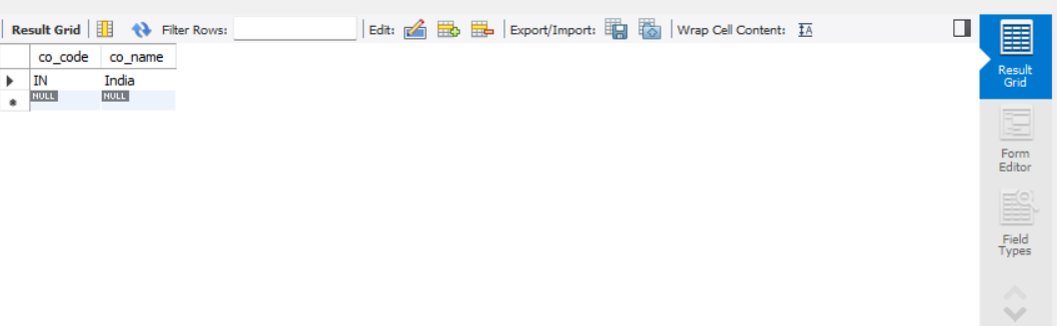

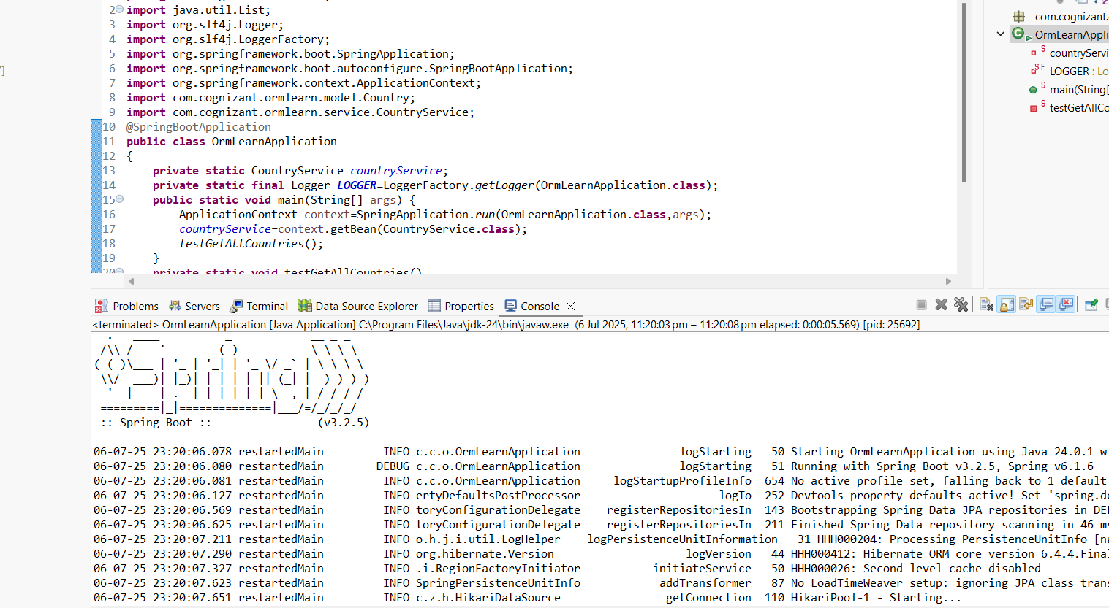

**Difference between JPA, Hibernate and Spring Data JPA   
pom.xml**

<?xml version="1.0" encoding="UTF-8"?>

<project xmlns="http://maven.apache.org/POM/4.0.0"

xmlns:xsi="http://www.w3.org/2001/XMLSchema-instance">

<modelVersion>4.0.0</modelVersion>

<parent>

<groupId>org.springframework.boot</groupId>

<artifactId>spring-boot-starter-parent</artifactId>

<version>3.2.5</version> <!-- STABLE version -->

<relativePath/>

</parent>

<groupId>com.cognizant</groupId>

<artifactId>orm-learn</artifactId>

<version>0.0.1-SNAPSHOT</version>

<name>orm-learn</name>

<description>Spring Data JPA + Hibernate + MySQL Demo</description>

<properties>

<java.version>17</java.version>

</properties>

<dependencies>

<dependency>

<groupId>org.springframework.boot</groupId>

<artifactId>spring-boot-starter-data-jpa</artifactId>

</dependency>

<dependency>

<groupId>com.mysql</groupId>

<artifactId>mysql-connector-j</artifactId>

<version>8.4.0</version>

</dependency>

<dependency>

<groupId>org.springframework.boot</groupId>

<artifactId>spring-boot-devtools</artifactId>

<scope>runtime</scope>

<optional>true</optional>

</dependency>

<dependency>

<groupId>org.springframework.boot</groupId>

<artifactId>spring-boot-starter-test</artifactId>

<scope>test</scope>

</dependency>

</dependencies>

<build>

<plugins>

<plugin>

<groupId>org.springframework.boot</groupId>

<artifactId>spring-boot-maven-plugin</artifactId>

</plugin>

</plugins>

</build>

</project>

**application.properties**

spring.application.name=orm-learn

logging.level.org.springframework=info

logging.level.com.cognizant=debug

logging.level.org.hibernate.SQL=trace

logging.level.org.hibernate.type.descriptor.sql=trace

logging.pattern.console=%d{dd-MM-yy} %d{HH:mm:ss.SSS} %-20.20thread %5p %-25.25logger**{25}** %25M %4L %m%n

spring.datasource.driver-class-name=com.mysql.cj.jdbc.Driver

spring.datasource.url=jdbc:mysql://localhost:3306/ormlearn

spring.datasource.username=Jeya

spring.datasource.password=Keerthi*2004

spring.jpa.hibernate.ddl-auto=validate

spring.jpa.hibernate.ddl-auto=update

spring.jpa.show-sql=true

spring.jpa.properties.hibernate.dialect=org.hibernate.dialect.MySQLDialect

**Employee.java**

**package** com.cognizant.ormlearn.model;

**import** jakarta.persistence.*;

@Entity

**public** **class** Employee {

@Id

@GeneratedValue(strategy = GenerationType.***IDENTITY***)

**private** Integer id;

**private** String name;

**private** String department;

**public** String getName() {

**return** name;

}

**public** **void** setName(String name) {

**this**.name=name;

}

**public** String getDepartment() {

**return** department;

}

**public** **void** setDepartment(String department) {

**this**.department=department;

}

**public** Integer getId() {

**return** id;

}

**public** **void** setId(Integer id) {

**this**.id=id;

}

}

**EmployeeRepository.java**

**package** com.cognizant.ormlearn.repository;

**import** com.cognizant.ormlearn.model.Employee;

**import** org.springframework.data.jpa.repository.JpaRepository;

**public** **interface** EmployeeRepository **extends** JpaRepository<Employee, Integer> {

}

**EmployeeService.java**

**package** com.cognizant.ormlearn.service;

**import** com.cognizant.ormlearn.model.Employee;

**import** com.cognizant.ormlearn.repository.EmployeeRepository;

**import** org.springframework.beans.factory.annotation.Autowired;

**import** org.springframework.stereotype.Service;

**import** jakarta.transaction.Transactional;

@Service

**public** **class** EmployeeService

{

@Autowired

**private** EmployeeRepository employeeRepository;

@Transactional

**public** **void** addEmployee(Employee employee)

{

employeeRepository.save(employee);

}

}

**OrmLearnApplication.java**

**package** com.cognizant.ormlearn;

**import** com.cognizant.ormlearn.model.Employee;

**import** com.cognizant.ormlearn.service.EmployeeService;

**import** org.springframework.beans.factory.annotation.Autowired;

**import** org.springframework.boot.CommandLineRunner;

**import** org.springframework.boot.SpringApplication;

**import** org.springframework.boot.autoconfigure.SpringBootApplication;

@SpringBootApplication

**public** **class** OrmLearnApplication **implements** CommandLineRunner

{

@Autowired

**private** EmployeeService employeeService;

**public** **static** **void** main(String[] args)

{

SpringApplication.*run*(OrmLearnApplication.**class**, args);

}

@Override

**public** **void** run(String... args) **throws** Exception

{

Employee emp = **new** Employee();

emp.setName("Ravi");

emp.setDepartment("HR");

employeeService.addEmployee(emp);

System.***out***.println("Employee added successfully!");

}

}

CREATE DATABASE orm_test;

USE orm_test;

SELECT*FROM Employee;

**Output**



